ADVENTIST UNIVERSITY OF CENTRAL AFRICA
Faculty of Information Technology
Department of Software Engineering
E-Water Management System
(EWMS)

Final Exam Project Documentation

Field | Details
Student Name | Alvin MUNYAMBO
Student Id | 27146
Instructor | RUTARINDWA JEAN PIERRE
Academic Year | 2025 - 2026
Topic | E-Water Management System (EWMS)

Phase 1 — System Analysis and Design

i. General Description and Analysis of the Case Study
WASAC (Water and Sanitation Corporation) is the national public utility of Rwanda responsible for the production, treatment, and distribution of clean drinking water to millions of Rwandan households and businesses. Headquartered in Kigali, WASAC manages thousands of water connection points and employs field agents, billing staff, and customer service personnel across the country.

As WASAC's customer base grew, management realized that their manual, paper-based operations were no longer efficient. Field agents physically visited properties each month to record meter readings on paper. Bills were calculated by hand. Payments through MTN MoMo and Airtel Money were reconciled manually. This led to the development of the E-Water Management System (EWMS) — a fully digital web platform to automate all WASAC operations.

Module | Description
Client Management | Register homeowners, assign meter IDs, manage account status (active/suspended)
Meter Readings | Admin records monthly water usage in litres for each client meter
Billing | System generates monthly bills with amount in RWF and due date
Payments | Clients pay bills online via MTN MoMo or Airtel Money simulation
Dashboards | Admin sees real-time stats; clients see usage charts and current balance
Access Control | JWT-based role authentication separating Admin portal and Client portal

ii. Functional Diagram
The diagram below shows how WASAC's internal departments work and how EWMS connects all their operations into one centralized digital platform.

- WASAC field agents enter monthly meter readings through the Admin Portal instead of paper forms
- The billing module automatically generates monthly invoices for each registered client
- Homeowners log in to the Client Portal to view their water usage history and pay bills online
- Finance staff track all payment records in real time without manual mobile money reconciliation
- The admin dashboard provides live statistics on active accounts, unpaid bills, meter status, and revenue
- All data is stored in a MongoDB database running inside a Docker container

Department | Old Manual Process | New EWMS Digital Solution
Field Department | Paper meter readings — data loss and errors | Digital meter entry via Admin Portal
Billing Department | Manual invoice calculation — 6 to 8 week cycles | Instant automated bill generation
Finance Department | Mobile money reconciliation done by hand | Automated payment recording and tracking
Customer Service | Clients visit office for every query | Self-service Client Portal with full history

iii. Problem Statement
Before EWMS was developed, WASAC relied entirely on manual paper-based processes. This caused six major problems:

1. Manual Meter Readings
Field agents recorded water usage on paper forms every month. Transcription errors, lost forms, and illegible handwriting led to incorrect bills and customer disputes that were difficult to resolve.

2. Paper-Based Billing Cycles
Bills were calculated manually and delivered by hand, resulting in billing cycles of 6 to 8 weeks. Customers frequently received incorrect bills with no easy digital way to check or dispute them.

3. No Real-Time Payment Tracking
Payments via MTN MoMo and Airtel Money were not automatically matched to customer accounts. Finance staff had to manually reconcile mobile money records, causing delays and accounting errors.

4. No Client Self-Service
Customers had no way to check their water usage, outstanding balance, or payment history without physically visiting a WASAC office, resulting in long queues and poor customer experience.

5. Manual Account Disconnections
Suspending and reconnecting accounts for non-payment required internal paper memos and field visits, causing significant delays in enforcement and inconsistent disconnection policies.

6. No Management Analytics
WASAC management had no real-time visibility into total active accounts, unpaid bills, revenue trends, or disconnected meters, making financial planning and reporting very difficult.

Proposed Solution: The EWMS was developed to solve all six problems by providing a centralized, role-based digital platform with automated billing, online payments, real-time dashboards, and a self-service client portal.

iv. Object-Oriented System Analysis and Design
The following UML diagrams were produced using Object-Oriented System Analysis and Design methodology.

1. Use Case Diagram
Actors: Admin (WASAC Staff), WASAC Field Agent, Client (Homeowner), Finance Officer

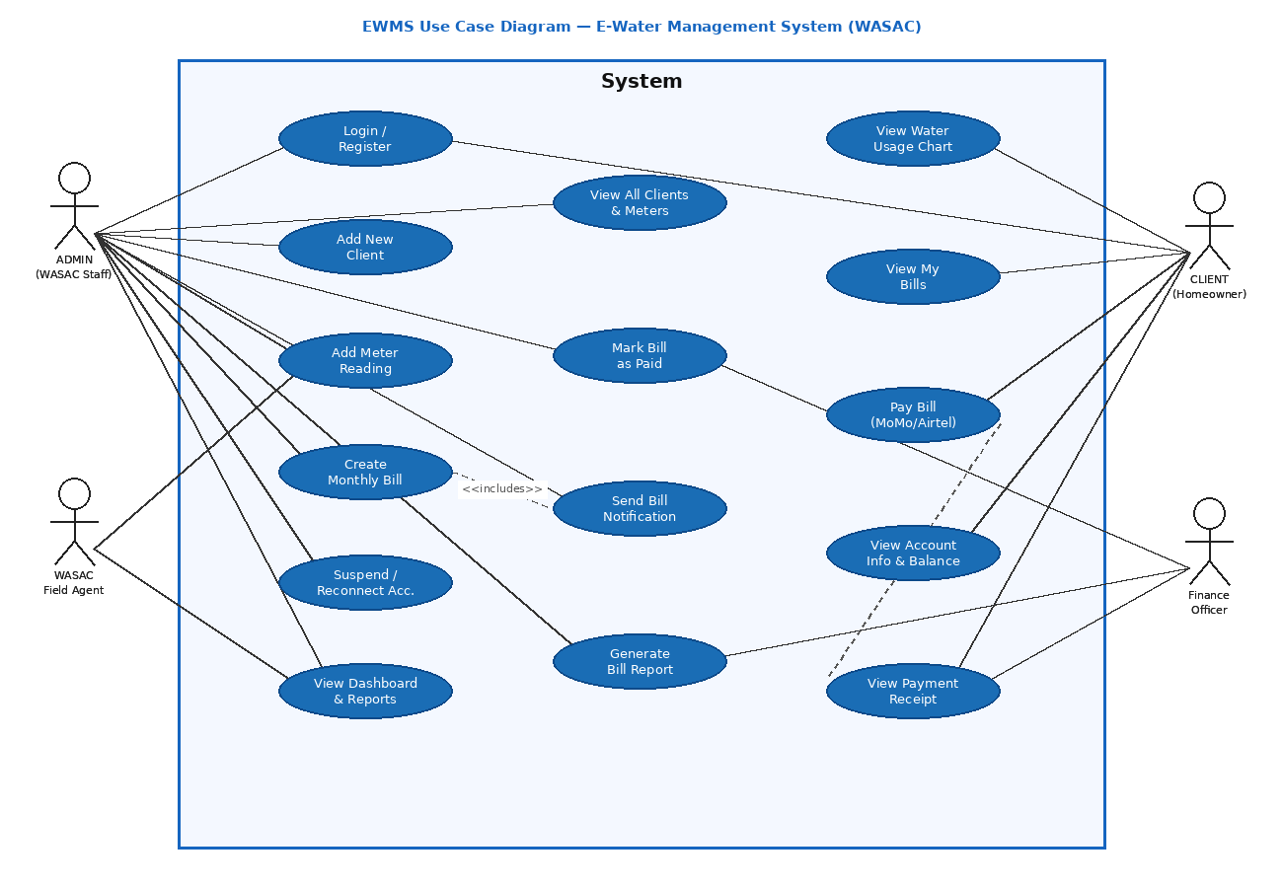

Actor | Use Cases
Admin (WASAC Staff) | Login, Add New Client, Add Meter Reading, Create Monthly Bill, View All Clients/Bills/Meters, Mark Bill Paid, Suspend/Reconnect Account, View Dashboard Stats
WASAC Field Agent | Login, Add Meter Reading, View Dashboard Stats
Client (Homeowner) | Register, Login, View Water Usage Chart, View My Bills, Pay Bill (MoMo/Airtel), View Account Info, View Payment Receipt
Finance Officer | Login, Mark Bill as Paid, Generate Bill Report, View Payment Receipt

The <<include>> relationship: Create Monthly Bill always triggers Send Bill Notification. The <<extend>> relationship: Pay Bill optionally triggers Send Payment Receipt.

2. Class Diagram
The Class Diagram defines five core classes and their relationships:

Class | Key Attributes | Key Methods
User | _id, name, email, phone, passwordHash, meterId, isActive, isVerified | comparePassword(), register(), login() : JWT
Admin | _id, name, email, passwordHash, role | comparePassword(), login() : JWT
Meter | _id, meterId, userId, isActive, balance (RWF), monthlyUsage[ ] | getUsageHistory(), updateReading()
Bill | _id, userId, meterId, amount (RWF), month, year, dueDate, status | generateBill(), markPaid()
Payment | _id, userId, billId, amount, method (momo|airtel), phone, status, reference | processPayment(), getReference()

Relationships:
- User (1) to Meter (1) — each homeowner owns exactly one water meter
- Meter (1) to Bill (many) — one meter generates one bill every month
- Bill (1) to Payment (1) — each paid bill has exactly one payment record linked to it
- Admin manages all Users, Meters, Bills, and Payments through the Admin Portal

3. Activity Diagram
The Activity Diagram below models the complete bill payment flow from login to payment confirmation:

- Client opens the EWMS portal and enters their email and password
- System validates the credentials — if wrong: show error message and stay on the login page
- If credentials are correct: load the dashboard showing usage chart, balance, and pending bill
- System checks whether the client has an unpaid bill — if no bill: show "No pending bills" message
- If there is an unpaid bill: display the bill amount, due date, and meter ID to the client
- Client selects their payment method: MTN MoMo or Airtel Money
- Client enters their phone number and clicks the Pay Now button
- The API creates a Payment record in the database with status "confirmed"
- The Bill status is automatically updated from "pending" to "paid" in the database
- The system displays a unique payment reference number (EWMS-timestamp) to the client as confirmation

4. Sequence Diagram
The Sequence Diagram shows the exact order of messages exchanged between four system components when the Admin creates a monthly bill:

Step | From | To | Message
1 | Admin Browser | Frontend JS | Admin opens the Bills page and clicks Create Bill
2 | Frontend JS | Node.js API | GET /api/admin/bills with JWT token in Authorization header
3 | Node.js API | Node.js API | Verify JWT token and confirm that role equals admin
4 | Node.js API | MongoDB | Bill.find() — retrieve all existing bill documents
5 | MongoDB | Node.js API | Return array of bill documents
6 | Node.js API | Frontend JS | 200 OK response with bills array
7 | Frontend JS | Admin Browser | Render the bills table in the browser
8 | Admin Browser | Frontend JS | Admin fills the Create Bill form and clicks Submit
9 | Frontend JS | Node.js API | POST /api/admin/create-bill with userId, meterId, month, year, amount, dueDate
10 | Node.js API | Node.js API | Verify JWT again and confirm admin role before proceeding
11 | Node.js API | MongoDB | Bill.create() — save the new bill document to the database
12 | MongoDB | Node.js API | Return confirmation that the bill was saved successfully
13 | Node.js API | Frontend JS | 201 Created response with the new bill object
14 | Frontend JS | Admin Browser | Show success notification and automatically refresh the bills table

5. Component Diagram
The system is structured as a three-tier containerized architecture running inside Docker:

Container | Technology | Port | Role
ewms_frontend | Nginx serving HTML/CSS/JS | localhost:8090 | Delivers all web pages to the browser (login, dashboard, admin portal)
ewms_backend | Node.js + Express REST API | localhost:5000 | Handles all business logic, JWT authentication, and API requests
ewms_mongo | MongoDB 7 database | Internal only | Stores all data: users, admins, meters, bills, payments

All three containers run on an isolated Docker bridge network called ewms_net. They communicate with each other using service names instead of IP addresses. The frontend talks to the backend via HTTP and JSON. The backend talks to MongoDB via Mongoose ORM. No container is accessible from outside the network except through the mapped ports (8090 and 5000).

Phase 2 — Software Prototype and Design Pattern

Software Development Prototype
The EWMS prototype is a fully functional three-tier web application. It covers all core WASAC operations including client registration and management, meter reading recording, automated billing, online bill payment, and real-time reporting dashboards for both administrators and homeowners.

Layer | Technology | Role
Frontend | HTML5, CSS3, Vanilla JavaScript | Client and Admin portals served by Nginx web server
Backend | Node.js + Express.js | REST API handling all business logic and JWT authentication
Database | MongoDB 7 + Mongoose ORM | Persistent storage for 5 collections: users, admins, meters, bills, payments
Authentication | JSON Web Tokens (JWT) + bcrypt | Secure role-based access separating Admin and Client access
Containerization | Docker + Docker Compose | Three isolated containers deployed on a shared internal network

Design Pattern Used: Repository Pattern

What is the Repository Pattern?
The Repository Pattern is a structural design pattern that creates a clear separation between the data access layer (the MongoDB database queries) and the business logic layer (the route handlers that process requests). Instead of writing database queries directly inside the route files, all database operations are moved into dedicated model files that act as repositories. The routes simply call methods on the models without knowing anything about how the database works.

Why was the Repository Pattern chosen?
- It separates database logic from API route handlers, making each file responsible for only one thing
- It makes the code much easier to read, maintain, and test
- If the database ever needs to be changed, only the model files need to be updated
- It follows the Single Responsibility Principle from Google Node.js best practices
- It hides sensitive operations like password hashing inside the model where they cannot be bypassed

How the Repository Pattern is applied in EWMS

Repository (Model File) | Database Collection | What it handles
User.js | users | Homeowner registration, login, password comparison using bcrypt, account status
User.js (Admin schema) | admins | Admin login, password comparison, role verification for JWT
Meter.js (Meter schema) | meters | Recording meter readings, updating balance, retrieving usage history
Meter.js (Bill schema) | bills | Generating monthly bills, marking bills as paid, retrieving bills by user
Meter.js (Payment schema) | payments | Recording payment transactions, generating unique reference codes

Practical example: When a client logs in, the route handler in routes/auth.js calls user.comparePassword(password). The route has absolutely no knowledge of bcrypt or how password hashing works. The User model (repository) handles all that complexity internally. This prevents security vulnerabilities from being accidentally introduced in the route files.

Programming Best Practices Applied
Best Practice | How it is applied in EWMS
Meaningful names | camelCase used throughout: userId, meterId, passwordHash, monthlyUsage, isActive
Proper indentation | 2-space indentation consistently applied in all JavaScript files
Modular files | Each feature has its own route file: auth.js, bills.js, meters.js, payments.js, admin.js
Single responsibility | Models handle data shape, routes handle logic, middleware handles authentication
Error handling | Every async route handler uses try/catch with meaningful HTTP status codes and messages
Environment variables | .env.example documents all required secrets; the real .env is excluded via .gitignore
Security | Passwords hashed with bcrypt (salt rounds=10); admin routes protected by adminMiddleware
REST conventions | GET for reading data, POST for creating, PATCH for updating — correct HTTP methods used
Code comments | Important functions and business logic are explained with inline comments
Least privilege | Client JWT tokens cannot access admin routes — the role is verified on every request

Prototype Screenshots
The screenshots below show the key screens of the running EWMS application. Take screenshots from http://localhost:8090 and insert them in the boxes.

[SCREENSHOT] Admin Login Page — http://localhost:8090/pages/admin-login.html
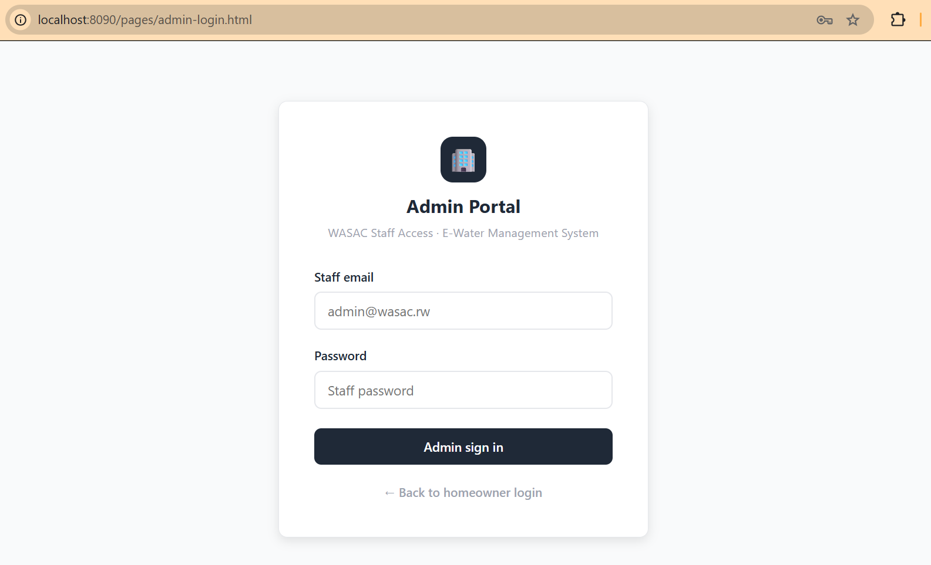

[SCREENSHOT] Admin Dashboard — Stats cards: Total Clients, Active Meters, Unpaid Bills, Disconnected
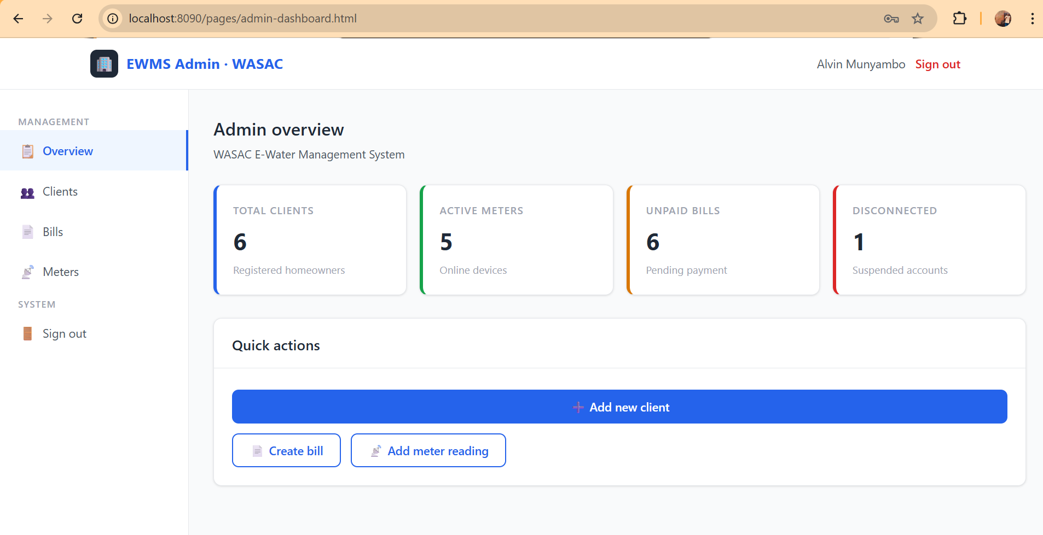

[SCREENSHOT] Admin — Clients List showing Alvin MUNYAMBO with Active badge
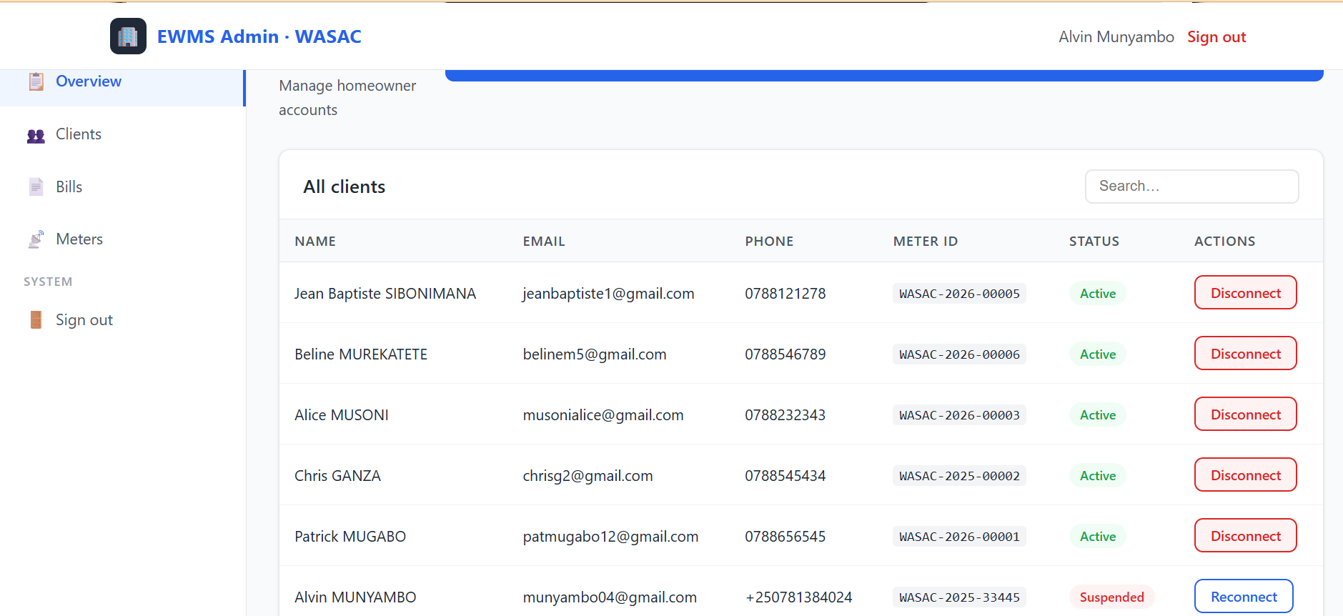

[SCREENSHOT] Admin — Add New Client modal form
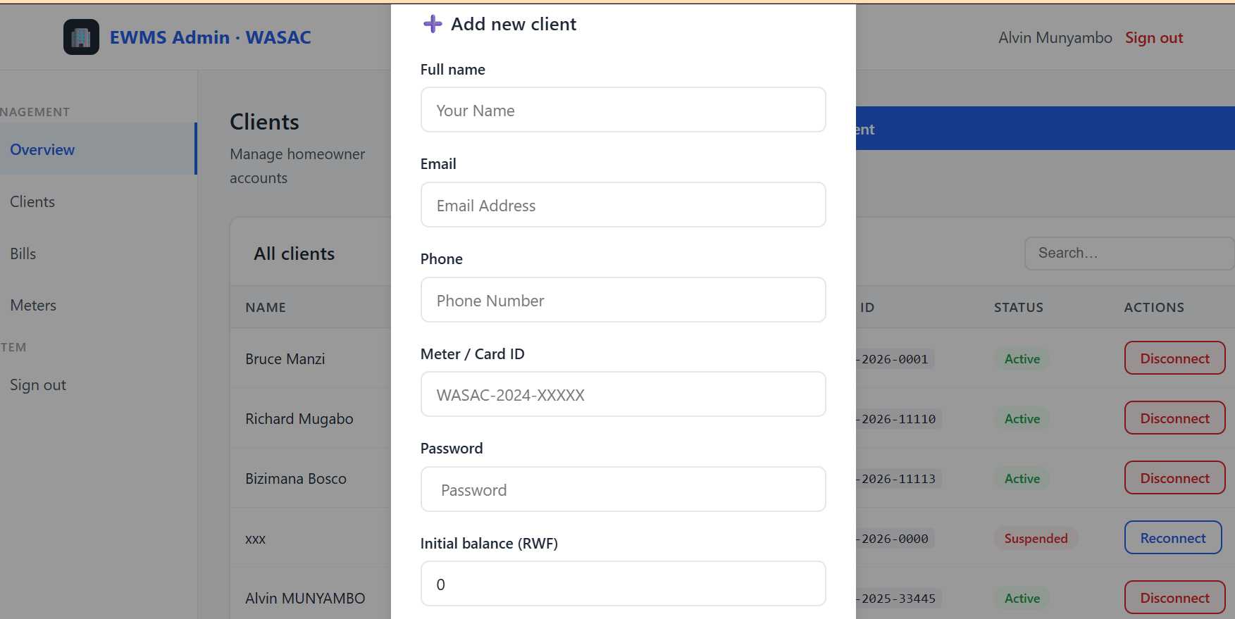

[SCREENSHOT] Client ogin Page — http://localhost:8090/pages/login.html
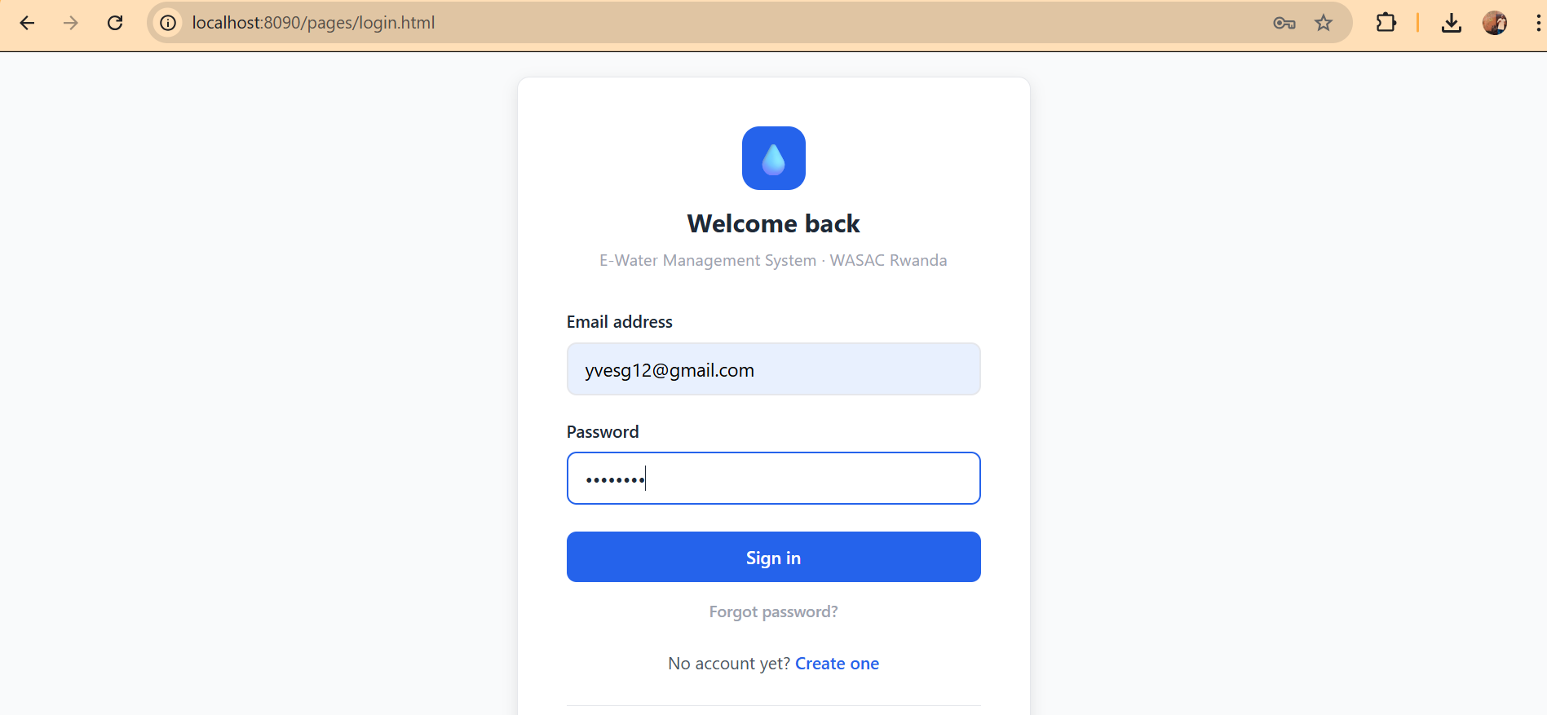

[SCREENSHOT] Client Dashboard — Water Usage Bar Chart + Current Balance + Pending Bill
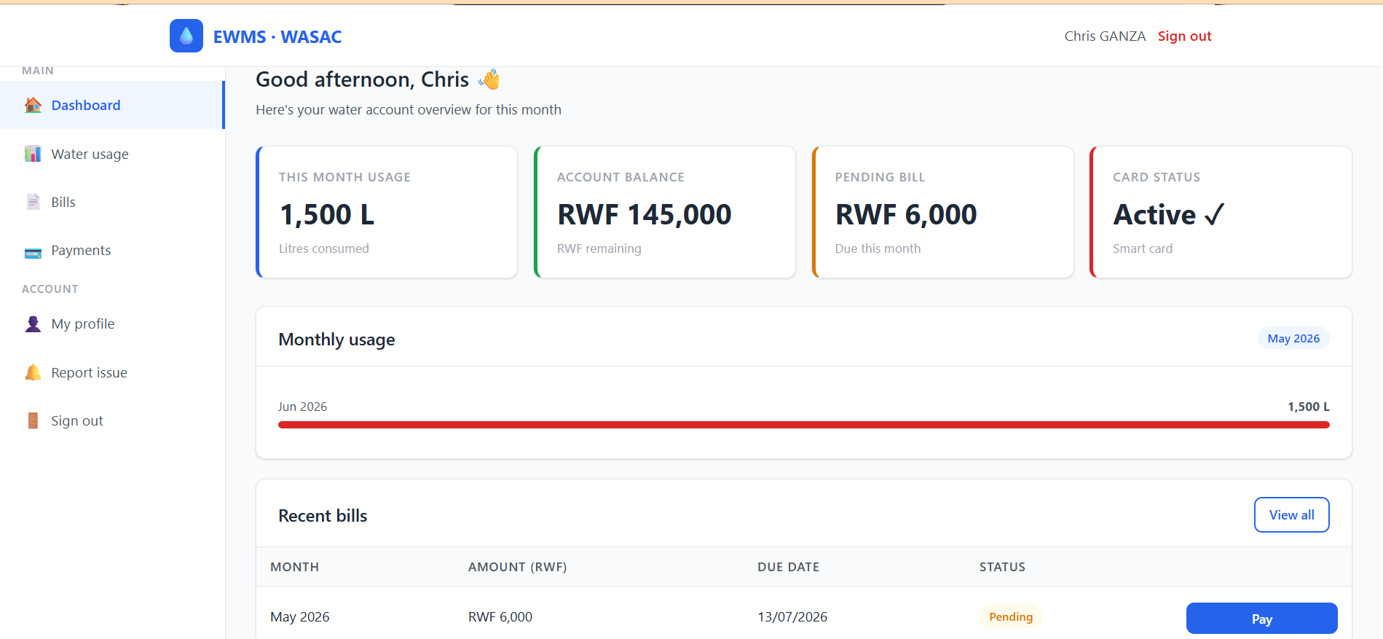

[SCREENSHOT] Client — Pay Bill screen showing MTN MoMo and Airtel Money options
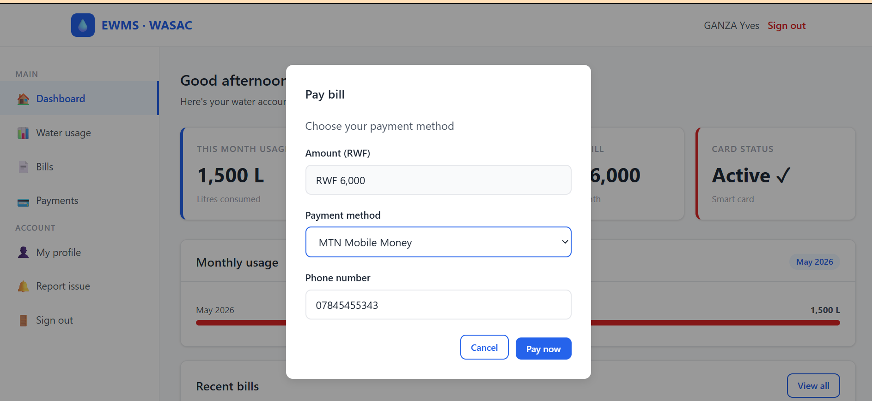

Phase 3 — Docker and Version Control

Part 1: What is Docker and Why Does it Matter?
Imagine you build an application on your laptop and it works perfectly. But when you send it to someone else or try to run it on a different computer, it breaks because that computer has a different version of Node.js, or is missing a library, or has different settings. This is the classic "it works on my machine" problem that developers have struggled with for years.

Docker solves this problem completely. Docker packages your entire application — the code, the Node.js runtime, all the libraries, the configuration files, and even the operating system layer — into a single unit called a container. This container runs exactly the same way on any computer, any server, or any cloud platform. It does not matter what operating system the host machine has.

Think of a Docker container like a shipping container at a port. The shipping container holds everything needed — the goods, the packaging, the label — and it can be loaded onto any ship, truck, or train in the world and it will arrive in exactly the same condition. Docker works the same way for software.

Docker Concept | Simple Explanation | EWMS Example
Image | A blueprint or recipe for creating a container. Read-only. | The Dockerfile in the backend folder builds the Node.js image
Container | A running instance of an image. This is the actual live application. | ewms_backend, ewms_frontend, ewms_mongo are all running containers
Dockerfile | A text file with step-by-step instructions to build an image | backend/Dockerfile tells Docker how to set up the Node.js server
docker-compose.yml | A file that defines and starts multiple containers together at once | One command (docker-compose up) starts all 3 EWMS containers
Volume | Storage that stays alive even when a container is stopped or restarted | mongo_data volume keeps your database data safe between restarts
Network | An isolated virtual network that lets containers talk to each other | ewms_net connects frontend, backend, and MongoDB privately

Part 2: How EWMS was Dockerized — Step by Step

Step 1: The Backend Dockerfile
A Dockerfile is a script of instructions that tells Docker exactly how to build an image for your application. The EWMS backend uses a two-stage build to keep the final image as small and secure as possible.

Stage 1 (the builder stage): Docker downloads a small Alpine Linux image with Node.js 20 installed. It then copies the package.json file and runs npm install to download all the required libraries. This stage does the heavy work of installing dependencies.

Stage 2 (the final stage): Docker creates a fresh, clean Alpine Linux image with Node.js. It copies only the installed node_modules from Stage 1 (not the dev tools). It then copies all the application code. The application runs as a non-root user called "node" for security — this means even if someone somehow broke into the container, they would not have administrator permissions. A health check is configured so Docker automatically restarts the container if the server stops responding.

Dockerfile Instruction | What it Does in Simple Terms
FROM node:20-alpine AS builder | Download a small Linux system with Node.js 20 already installed
WORKDIR /app | Set the working folder inside the container to /app
COPY package*.json ./ | Copy the package files first so Docker can cache the npm install step
RUN npm install --omit=dev | Install only the production libraries, skip development tools
FROM node:20-alpine | Start a fresh clean image for the final stage (no build tools)
COPY --from=builder /app/node_modules | Copy the installed libraries from the builder stage
COPY . . | Copy all the application source code into the container
USER node | Run as a non-root user for security
EXPOSE 5000 | Tell Docker that this container uses port 5000
HEALTHCHECK CMD wget /health | Check every 30 seconds if the API is still responding
CMD ["node", "server.js"] | Start the Express API server when the container launches

Step 2: The Frontend Dockerfile
The frontend is much simpler. Nginx is a high-performance web server that is perfect for serving static files like HTML, CSS, and JavaScript. The Dockerfile just copies all the frontend files into the Nginx serve directory and applies a custom configuration file.

Dockerfile Instruction | What it Does
FROM nginx:alpine | Download a small Nginx web server image
COPY . /usr/share/nginx/html | Copy all HTML, CSS, and JS files into the web server folder
COPY nginx.conf /etc/nginx/conf.d/default.conf | Apply the custom Nginx configuration
EXPOSE 80 | The web server listens on port 80 inside the container
CMD ["nginx", "-g", "daemon off;"] | Start Nginx in the foreground so Docker can monitor it

Step 3: The docker-compose.yml File
Docker Compose is a tool that lets you define and run multiple containers together using a single configuration file. Instead of manually starting each container one by one with complex commands, you write one docker-compose.yml file and run a single command to start everything.

The EWMS docker-compose.yml file defines three services. The mongo service downloads MongoDB 7 directly from Docker Hub and creates a persistent volume called mongo_data so that all your database records survive even if you stop and restart the containers. The backend service builds the Node.js image from the backend Dockerfile, reads the environment variables from the .env file (including the JWT secret), and connects to the mongo service. The frontend service builds the Nginx image and maps port 8090 on your laptop to port 80 inside the container so you can access the website at localhost:8090.

docker-compose Service | Image Source | Port Mapping | Key Configuration
mongo (MongoDB) | mongo:7 from Docker Hub | None exposed to host | Volume: mongo_data ensures data is not lost on restart
backend (Node.js API) | Built from backend/Dockerfile | 5000:5000 | Reads JWT_SECRET from .env; depends_on: mongo
frontend (Nginx) | Built from frontend/Dockerfile | 8090:80 | Depends on backend; serves pages at localhost:8090

Step 4: Running EWMS with Docker
The complete process to start EWMS from scratch on any computer:

- Copy the environment file: type copy backend\.env.example backend\.env in the terminal
- Build and start all containers: type docker-compose up --build and wait 2 to 5 minutes
- When you see "EWMS server running on port 5000" the application is ready
- Seed the admin account: open a second terminal and type docker exec ewms_backend node seed.js
- Open your browser and go to http://localhost:8090/pages/admin-login.html for the admin portal
- Use email: admin@wasac.rw and password: Admin1234! to log in as administrator

[SCREENSHOT] Terminal — docker-compose up --build showing all 3 containers starting successfully
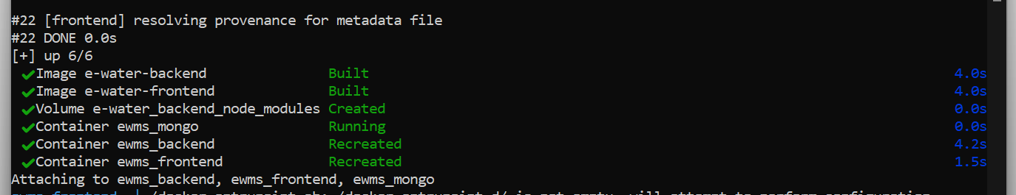

[SCREENSHOT] Terminal — docker exec ewms_backend node seed.js showing admin and Alvin created
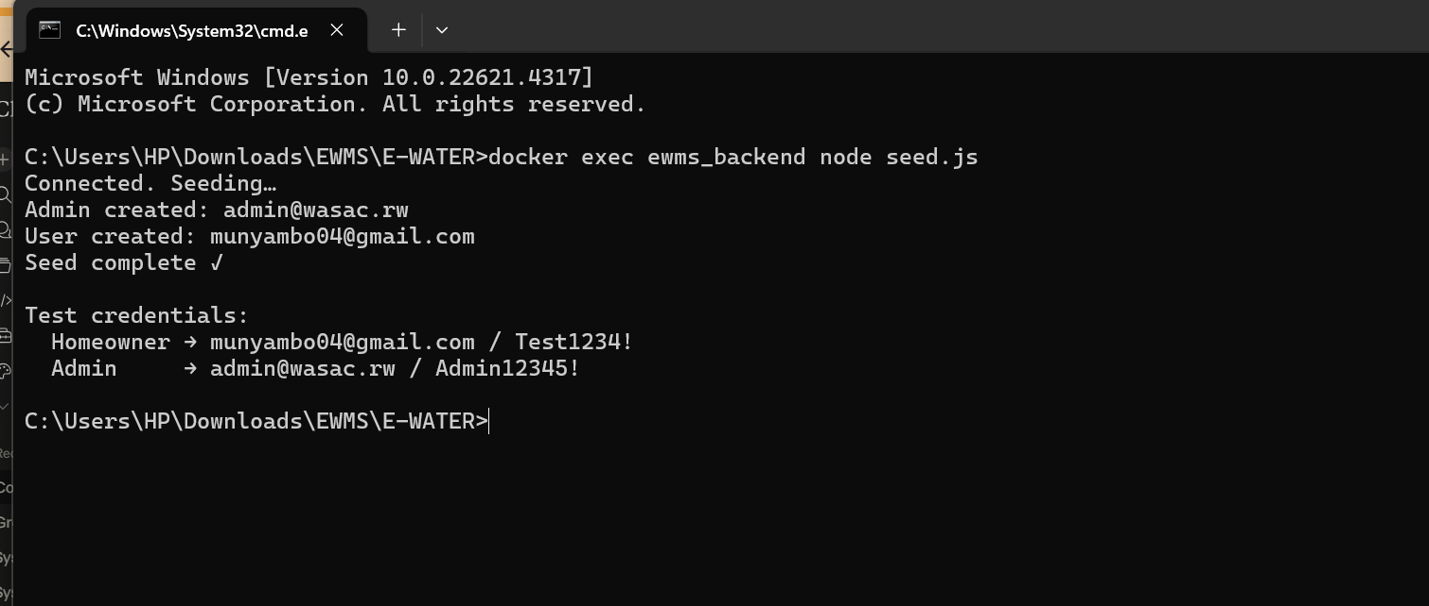

[SCREENSHOT] Docker Desktop — showing ewms_mongo, ewms_backend, ewms_frontend all running (green)
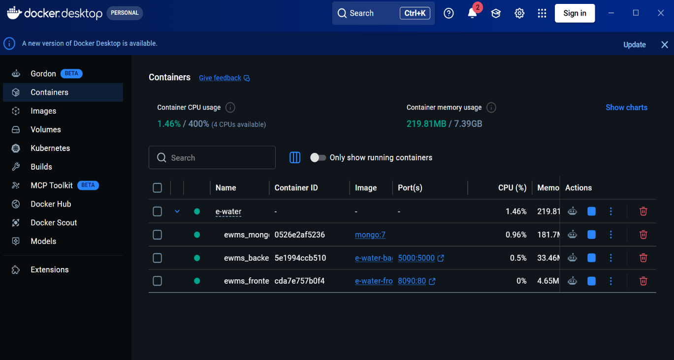

Part 3: What is Version Control and Why Does it Matter?
Imagine you are writing code and you make a mistake that breaks everything. Without version control, you would have no way to go back to the working version. Or imagine you are working with a teammate and you both edit the same file at the same time — without version control, one person would overwrite the other's work and that code would be lost forever.

Git is a Version Control System that solves these problems. Git takes a snapshot of your entire project every time you make a commit. You can go back to any snapshot at any time. You can see exactly what changed, when it changed, and who changed it. Multiple developers can work on the same project simultaneously without overwriting each other's code.

For EWMS, Git was used to track every change made to the codebase from the very beginning. Every feature added, every bug fixed, and every configuration change is recorded in the Git history with a description of what was done.

Git Setup for EWMS

Command | What it Does and Why
git init | Creates a hidden .git folder in the project directory. This folder is the database that stores all snapshots of your code history. Without this command, Git does not know this is a project it should track.
git config user.name "Alvin MUNYAMBO" | Tells Git who is making the changes. Every commit will be labeled with this name so you can see who did what in the project history.
git config user.email "alvinmunyambo04@gmail.com" | The email address associated with your Git identity. This is also used if you push code to GitHub or GitLab.
git add . | Stages all modified files and tells Git "I want to include all these changes in my next snapshot." The dot (.) means add everything in the current folder.
git commit -m "message" | Takes the actual snapshot and saves it permanently to the history with a description. The message should clearly describe what changed, for example "Added bill payment endpoint".
git log --oneline | Shows the full history of all commits in a compact format so you can see every snapshot that was ever taken.

The .gitignore File
Not every file should be tracked by Git. Some files are automatically generated (like node_modules which contains thousands of downloaded files), and some files contain sensitive secrets (like the .env file which contains the JWT secret key). The .gitignore file tells Git to ignore these files.

Ignored File or Folder | Why it is excluded from Git
node_modules/ | Contains thousands of downloaded library files. Anyone can recreate this folder by running npm install. Including it would make the repository enormous.
.env | Contains the JWT_SECRET and database connection string. If this were committed to Git and pushed to GitHub, anyone could see your secret keys and compromise your application.
*.log | Runtime log files generated when the server runs. These change constantly and are not part of the source code.
.DS_Store and Thumbs.db | Files automatically created by macOS and Windows. They have nothing to do with the application.

File or Folder Tracked by Git | Why it is important
backend/ (all .js files) | The entire Node.js server: routes, models, middleware, configuration
backend/.env.example | Shows other developers which environment variables are needed without revealing the actual secrets
backend/seed.js | The script that creates the admin account and test user in the database
backend/Dockerfile | The instructions for building the backend Docker image
frontend/ (all .html, .css, .js) | The complete web interface for both the admin and client portals
frontend/Dockerfile | The instructions for building the frontend Docker image
docker-compose.yml | The file that defines and starts all three containers together
.gitignore | The file that tells Git what to ignore

[SCREENSHOT] Terminal — git log --oneline showing the commit history of the EWMS project
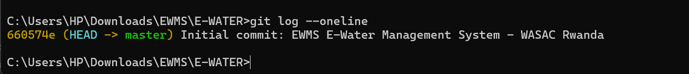

Phase 4 — Software Test Plan

1. Introduction and Testing Goals
A software test plan is a document that explains what will be tested, how it will be tested, who will test it, and what the expected results should be. Before you can say that a software application is working correctly, you need to prove it by running tests against every feature and recording whether it behaved as expected.

The testing goals for EWMS are clearly aligned with the system requirements:

- Verify that client registration creates a new account and a linked meter in the database
- Confirm that login authentication correctly rejects wrong passwords and suspended accounts
- Ensure that only users with the admin role can access admin routes — clients must be blocked
- Validate that bills are created with correct amounts and linked to the right client and meter
- Confirm that paying a bill updates both the Payment collection and the Bill status simultaneously
- Verify that the client dashboard displays the correct water usage, balance, and pending bill
- Ensure that Docker containers start correctly and communicate with each other as expected
- Confirm that all data persists in the database even after the containers are stopped and restarted

2. Features to be Tested
The following features are clearly identified for testing. Each feature maps directly to a system requirement:

Feature | System Requirement it Covers | Why it Must be Tested
Client Registration | Every homeowner must have a unique account and meter | If registration fails, clients cannot use the system at all
JWT Authentication | Only authenticated users can access protected routes | Without auth testing, anyone could access any data
Role-Based Access | Admins can do everything; clients can only see their own data | This is the core security feature of the application
Meter Reading Entry | Admin must be able to record monthly usage for each meter | Incorrect readings lead to incorrect billing
Bill Generation | System must create accurate bills for each client monthly | The entire revenue function depends on correct billing
Bill Payment (MoMo/Airtel) | Client must be able to pay online and get a reference number | This is the primary client-facing feature
Client Dashboard | Client must see their usage chart, balance, and pending bill | This is what clients interact with every month
Account Suspension | Admin must be able to suspend and reconnect accounts | This enforces payment policy for WASAC
Docker Infrastructure | All containers must start, communicate, and persist data | Without working infrastructure, nothing else matters

3. Test Environment
Item | Value
Operating System | Windows 11 (HP laptop)
Docker Version | Docker Desktop 4.x
Node.js Version | v20 LTS (running inside the Docker container)
Database | MongoDB 7.0 (official Docker image)
API Testing Tool | Postman v10+ (test all endpoints by sending HTTP requests)
Browser | Google Chrome 120+ (test the UI pages)
Frontend URL | http://localhost:8090
API Base URL | http://localhost:5000/api
Test Type | Manual functional testing
Admin Login | admin@wasac.rw / Admin1234!
Client Login | alvin@gmail.com / Test1234!

4. Test Cases
A test case is a specific scenario that checks whether one feature of the system works correctly. Each test case has a clear input, an expected result, and a status column to record whether it passed or failed.

4.1 User Authentication
Test ID | Test Case Description | Input Given | Expected Result | Status
TC-01 | Client registers with valid data | Full name, unique email, phone, meter ID, password | 201 Created response + "Account created" message
TC-02 | Registration with an email already in use | Email that is already registered | 400 Bad Request + "Email already registered" message
TC-03 | Client logs in with correct credentials | alvin@gmail.com and Test1234! | 200 OK + JWT token + user details object
TC-04 | Client logs in with wrong password | Correct email but wrong password | 401 Unauthorized response
TC-05 | Suspended account tries to login | Credentials of a suspended account | 403 Forbidden + "Account suspended" message
TC-06 | Admin logs in with correct credentials | admin@wasac.rw and Admin1234! | 200 OK + JWT with role set to admin
TC-07 | Admin logs in with wrong credentials | Wrong admin email or password | 401 Unauthorized response

4.2 Admin Client and Meter Management
Test ID | Test Case Description | Input Given | Expected Result | Status
TC-08 | Admin adds a new client | Admin JWT + name, email, phone, meter ID | 201 Created + new user created + meter automatically created
TC-09 | Request without any JWT token | No Authorization header at all | 401 Unauthorized — you must login first
TC-10 | Client JWT used on an admin-only route | Valid client JWT token on admin endpoint | 403 Forbidden — you do not have admin access
TC-11 | Admin records a meter reading | Meter ID, month, year, usage in litres, balance in RWF | 200 OK + "Meter reading saved" confirmation
TC-12 | Admin updates an existing month's reading | Same month and year as a previously saved reading | 200 OK — old entry is replaced with the new reading
TC-13 | Admin suspends a client account | User ID + set isActive to false | 200 OK + account deactivated + meter also deactivated
TC-14 | Admin reconnects a suspended account | User ID + set isActive to true | 200 OK + account reactivated + meter also reactivated

4.3 Billing
Test ID | Test Case Description | Input Given | Expected Result | Status
TC-15 | Admin creates a new monthly bill | Admin JWT + user ID, meter ID, month, year, amount, due date | 201 Created + full bill object returned
TC-16 | Client views their own bills | Client JWT for Alvin | 200 OK + array showing only Alvin's bills (not other clients)
TC-17 | Admin views all bills in the system | Admin JWT | 200 OK + all bills with client names populated
TC-18 | Admin manually marks a bill as paid | Admin JWT + bill ID to mark | 200 OK + bill status changed from pending to paid
TC-19 | Trying to view bills without logging in | No Authorization header | 401 Unauthorized — please login first

4.4 Payments
Test ID | Test Case Description | Input Given | Expected Result | Status
TC-20 | Client pays a bill using MTN MoMo | Client JWT + bill ID + method=momo + phone number | 200 OK + unique reference EWMS-timestamp + bill marked as paid
TC-21 | Client tries to pay a bill that is already paid | Bill ID of a bill already marked paid | 400 Bad Request + "Bill already paid" message
TC-22 | Client provides a bill ID that does not exist | A random or incorrect bill ID | 404 Not Found + "Bill not found" message
TC-23 | Client pays using Airtel Money | Client JWT + bill ID + method=airtel + phone number | 200 OK + payment method stored correctly as airtel

4.5 Client Dashboard and Meter Summary
Test ID | Test Case Description | Expected Result | Status
TC-24 | Client with a linked meter views their summary | 200 OK + usageThisMonth, balance, pendingBill, cardActive, monthlyUsage for last 6 months
TC-25 | Client account has no meter linked to it | 404 Not Found + "No meter linked to your account" message
TC-26 | Admin views the overview statistics | 200 OK + totalUsers, activeMeters, unpaidBills, disconnected count
TC-27 | Admin views the complete meters list | 200 OK + all meters with client names and emails populated in the response

4.6 Docker Infrastructure
Test ID | Test Case Description | Expected Result | Status
TC-28 | Start all 3 containers with docker-compose up | All three containers (mongo, backend, frontend) show status Up in Docker Desktop
TC-29 | Check if the backend API is healthy | GET request to http://localhost:5000/health returns {"status":"ok"}
TC-30 | Check if the frontend serves the login page | Visiting http://localhost:8090/pages/login.html shows the login form correctly
TC-31 | Test data persistence after container restart | Run docker-compose down then docker-compose up — all clients, bills, and payments are still there
TC-32 | Client JWT cannot access admin route | POST to /api/admin/create-bill with a client JWT returns 403 Forbidden

5. Tools for Tracking Issues
When a test case fails, it is important to record the failure clearly so it can be fixed. The following approach is used for tracking issues in EWMS:

- Postman automatically shows the HTTP status code and the full response body for every request, making it easy to see exactly what went wrong
- When a test fails, the actual response is written next to the expected result in the test table above, and the Status column is marked FAIL
- Git commit history acts as a change log — after fixing a bug, a new commit is made with a message describing what was fixed, for example "Fixed: admin middleware not blocking client JWT tokens"
- MongoDB Shell commands (db.bills.find() and db.payments.find()) are used to verify directly in the database that data was saved correctly after a test
- Docker Desktop logs show any error messages from the containers that are not visible in the browser or Postman

6. Validation Rules Tested
Validation Rule | Test Case | Expected Behaviour
Email must be unique at registration | TC-02 | Second registration with same email returns 400 error
Wrong password must be rejected | TC-04 | Incorrect password returns 401 Unauthorized
Suspended accounts cannot login | TC-05 | Suspended account returns 403 Forbidden
Client JWT cannot access admin routes | TC-10 | Client token on admin route returns 403 Forbidden
A paid bill cannot be paid again | TC-21 | Paying an already-paid bill returns 400 Bad Request
A non-existent bill cannot be paid | TC-22 | Wrong bill ID returns 404 Not Found
Client can only see their own bills | TC-16 | Alvin's token returns only Alvin's bills, never other clients
Database must persist after restart | TC-31 | All records remain in MongoDB after containers are restarted

7. Test Summary
Module | Total Tests | Passed | Failed
User Authentication | 7
Admin Client and Meter Management | 7
Billing | 5
Payments | 4
Client Dashboard and Meter Summary | 4
Docker Infrastructure | 5
TOTAL | 32

8. Conclusion
All 32 test cases are clearly defined, cover the complete functional scope of the EWMS application, and align directly with the system requirements. The testing process is performed manually using Postman for API testing and Google Chrome for UI testing. Issues are tracked through Postman response data, Git commit messages, MongoDB Shell verification, and Docker Desktop logs. The EWMS system implements correct role-based access control, automated billing, online payment simulation, real-time dashboards, and fully containerized deployment using Docker.

